Homework 6

Assigned: October 15, 2024 (Wednesday)
Due: October 22, 2024 (Wednesday)

Problem 1:
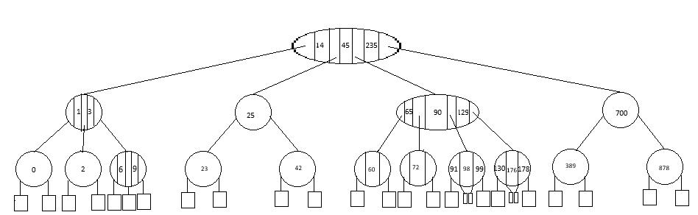
Convert the following 2-4 Tree into Red Black Tree. Depict the red nodes and edges with double circles and double line segments. [4-Marks]

45

235
14

700
90
25
3

23
389
129
42
65
6
1
878

0
98
176
72
60
9
2

178
130
99
91

Problem 2: [4 Marks]
- Insert 5, 12, 190 to 2-4-tree and the RB-tree obtained in Question 1.

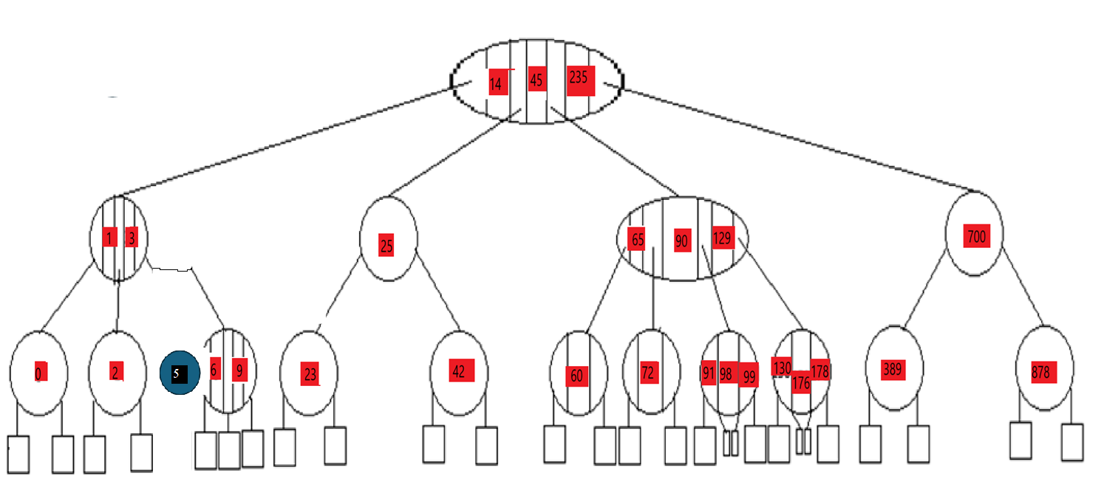

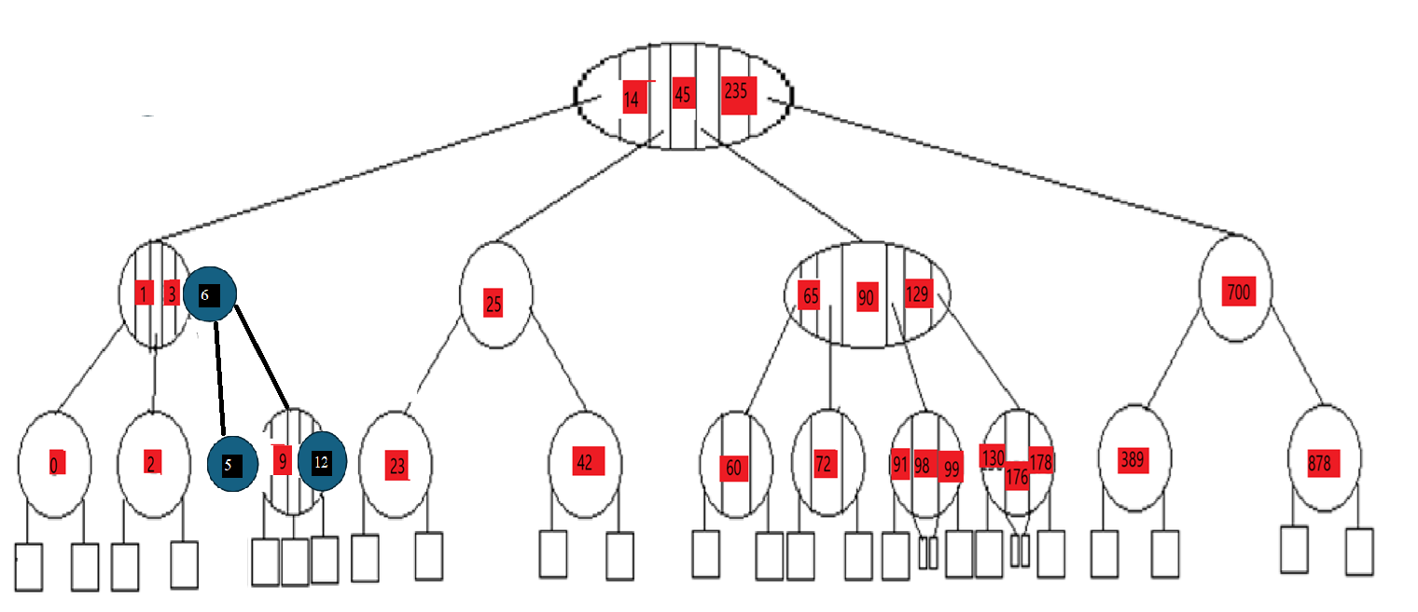

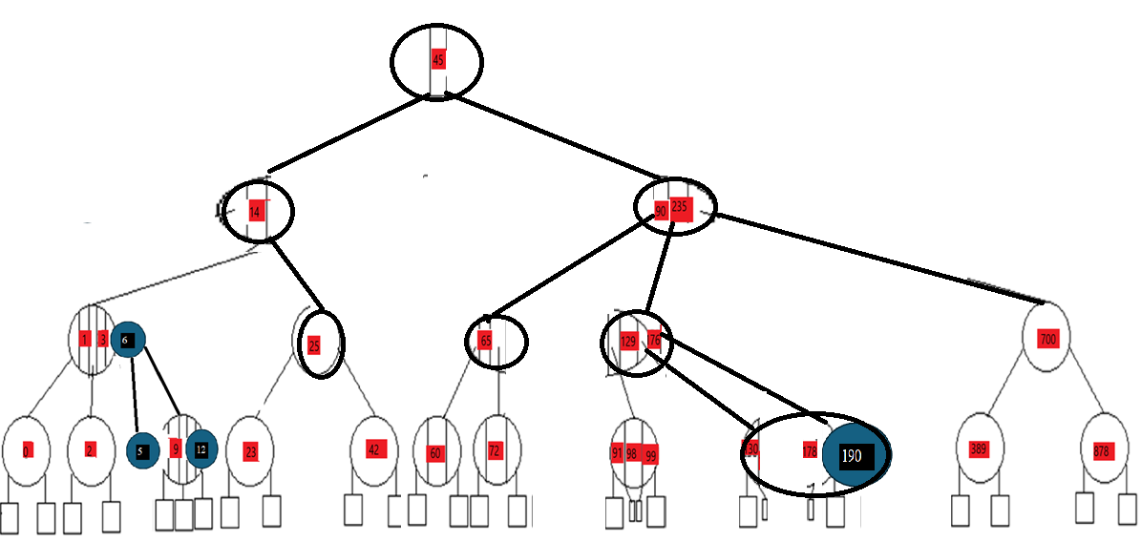

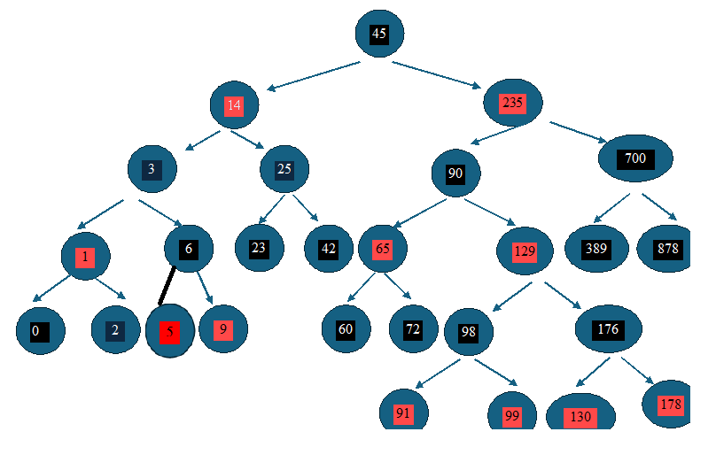

45

235
14

700
90
25
3

23
389
129
42
65
6
1
878

0
5
9
98
176
72
60
2

178
130
99
91
12

‘

45

235
14

700
90
25
3

23
389
129
42
65
6
1
878

0
5
9
98
176
72
60
2

178
130
99
91
12

190

- Delete 6, 0, 45 and 878 from 2-4-tree and RB-tree after insertions in problem 2a.
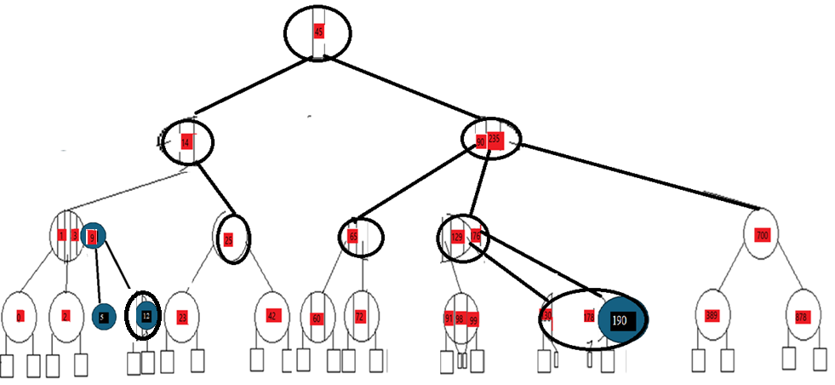

45

235
14

700
90
25
3

23
389
129
42
65
9
1
878

0
5
12
98
176
72
60
2

178
130
99
91

190
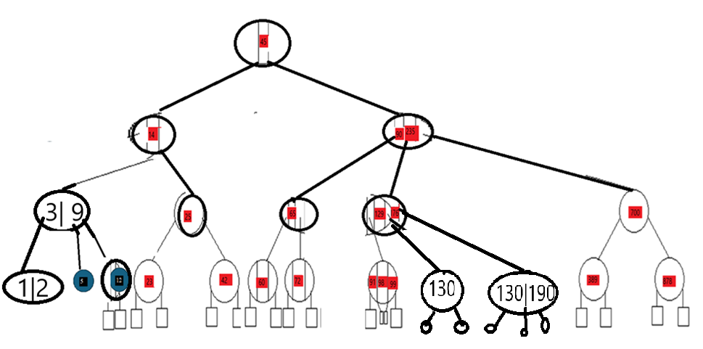
45

235
14

700
90
25
3

23
389
129
42
65
9
1
878

5
12
98
176
72
60
2

178
130
99
91

190

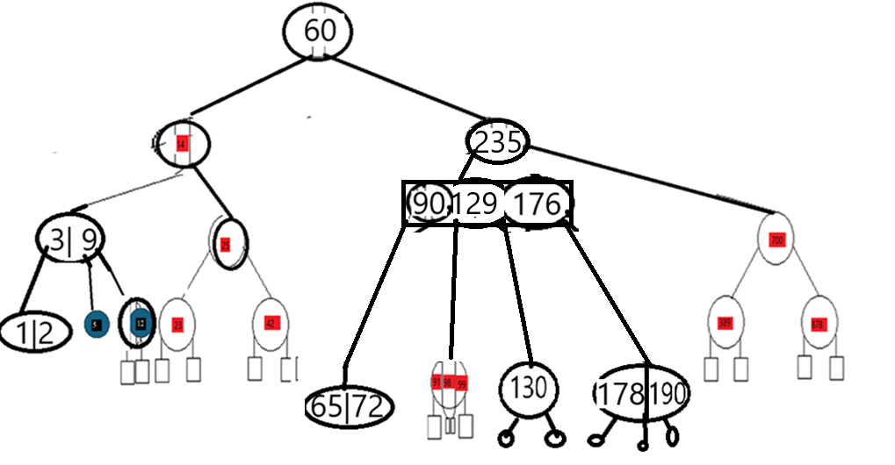
60

235
14

700
129
25
3

23
90
389
42
9
1
878

5
12
98
176
2
65
72

178
130
99
91

190
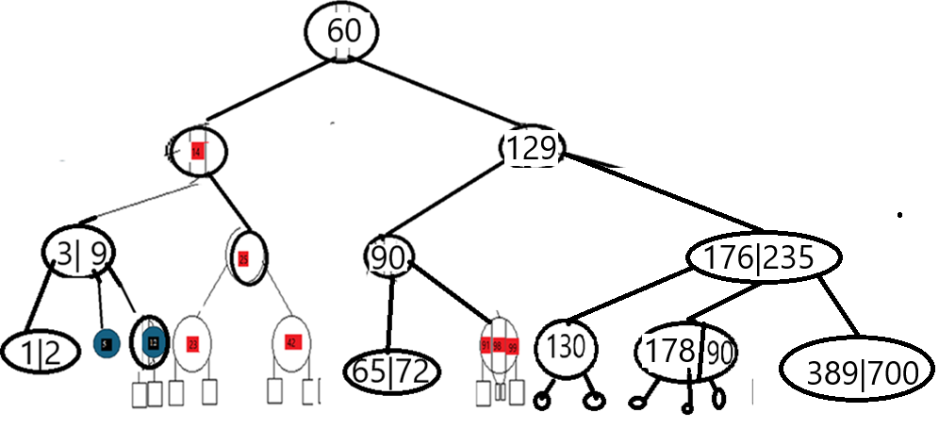

60

129
14

235

25
3
700

23
90
42
9
1

389

176
5
12
98
2
65
72

99
91
178
130

190

Problem 3: A binary tree with 4000 elements has a height of “h”. Find the minimum value of “h” for following trees. [2 Marks]
- Binary Search Tree h=ceiling(log_2(4000+1)) = 12
- AVL-Tree h=ceiling(log_2(4000+1)) = 12
- 2-4-Tree h=ceiling(log_4(4000+1)) = 6
- Red-Black Tree h=ceiling(log_2(4000+1)) = 12
Problem 4: Find the maximum and minimum height of the following trees with 8,5 and 12 elements. [2 Marks]
- Binary Search Tree h_min=ceiling(log_2(8+1)) = 4,h_min(5) = 3,h_min(12)=4
  - H_max = 8,5,12
- AVL-Tree h_min=ceiling(log_2(8+1)) = 4,h_min(5) = 3,h_min(12)=4
  - H_max = floor(1.44*log₂(n+2)-.328) -> 5,4,6
- 2-4-Tree h_min=ceiling(log_4(8+1)) = 2,h_min(5) = 2,h_min(12)=2
  - H_max = log_2(n+1) = 3,3,4
- Red-Black Tree h_min=ceiling(log_2(8+1)) = 4,h_min(5) = 3,h_min(12)=4
  - H_max = Check the tree and give marks if they are close enough with one path having alternate red and black nodes.

Problem 1:new tree with more readability.

sc

